How to create a house and land packages Item for the Googong Page

Step 1:
In a new tab open the media library
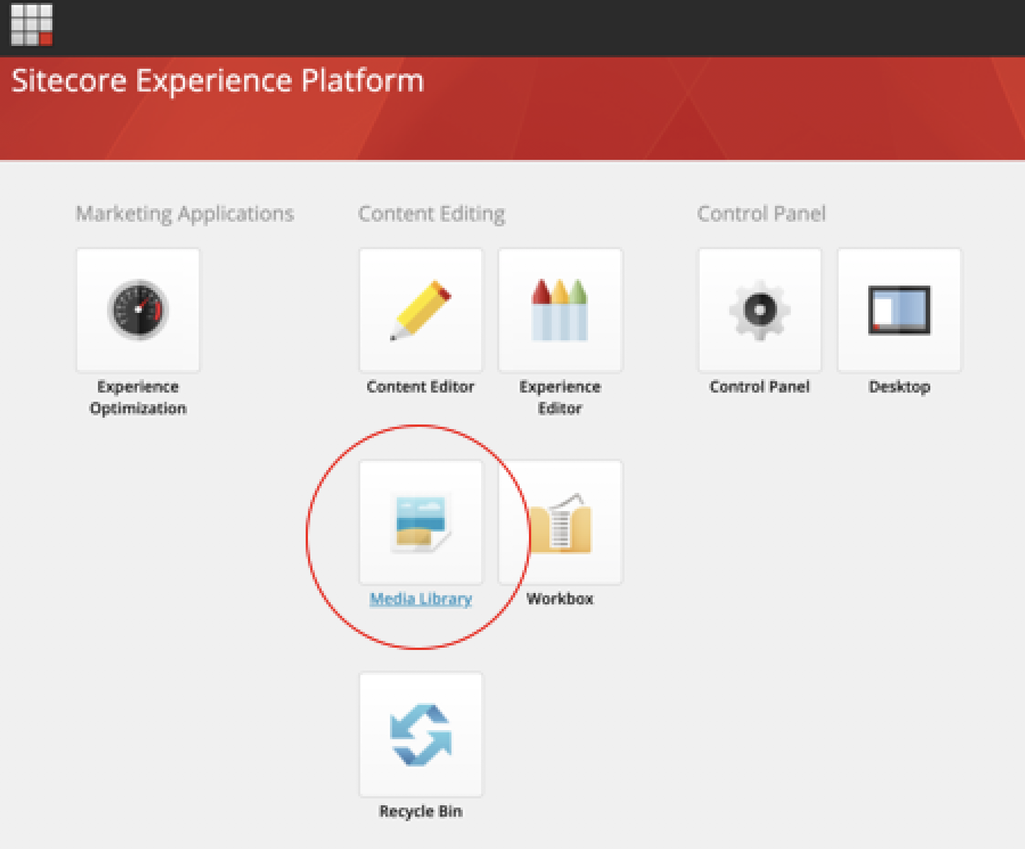

Step 2:
navigate to PEET -> Tile Images -> ACT -> Googong
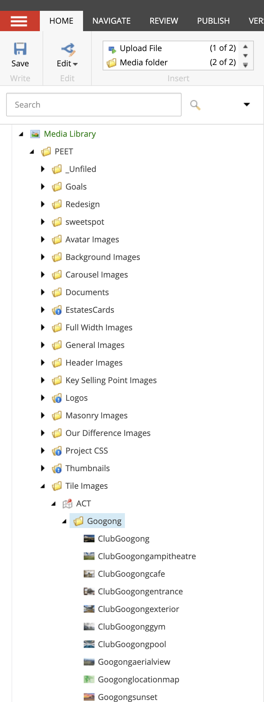

Step 3:
Then using the options, click the upload file button.

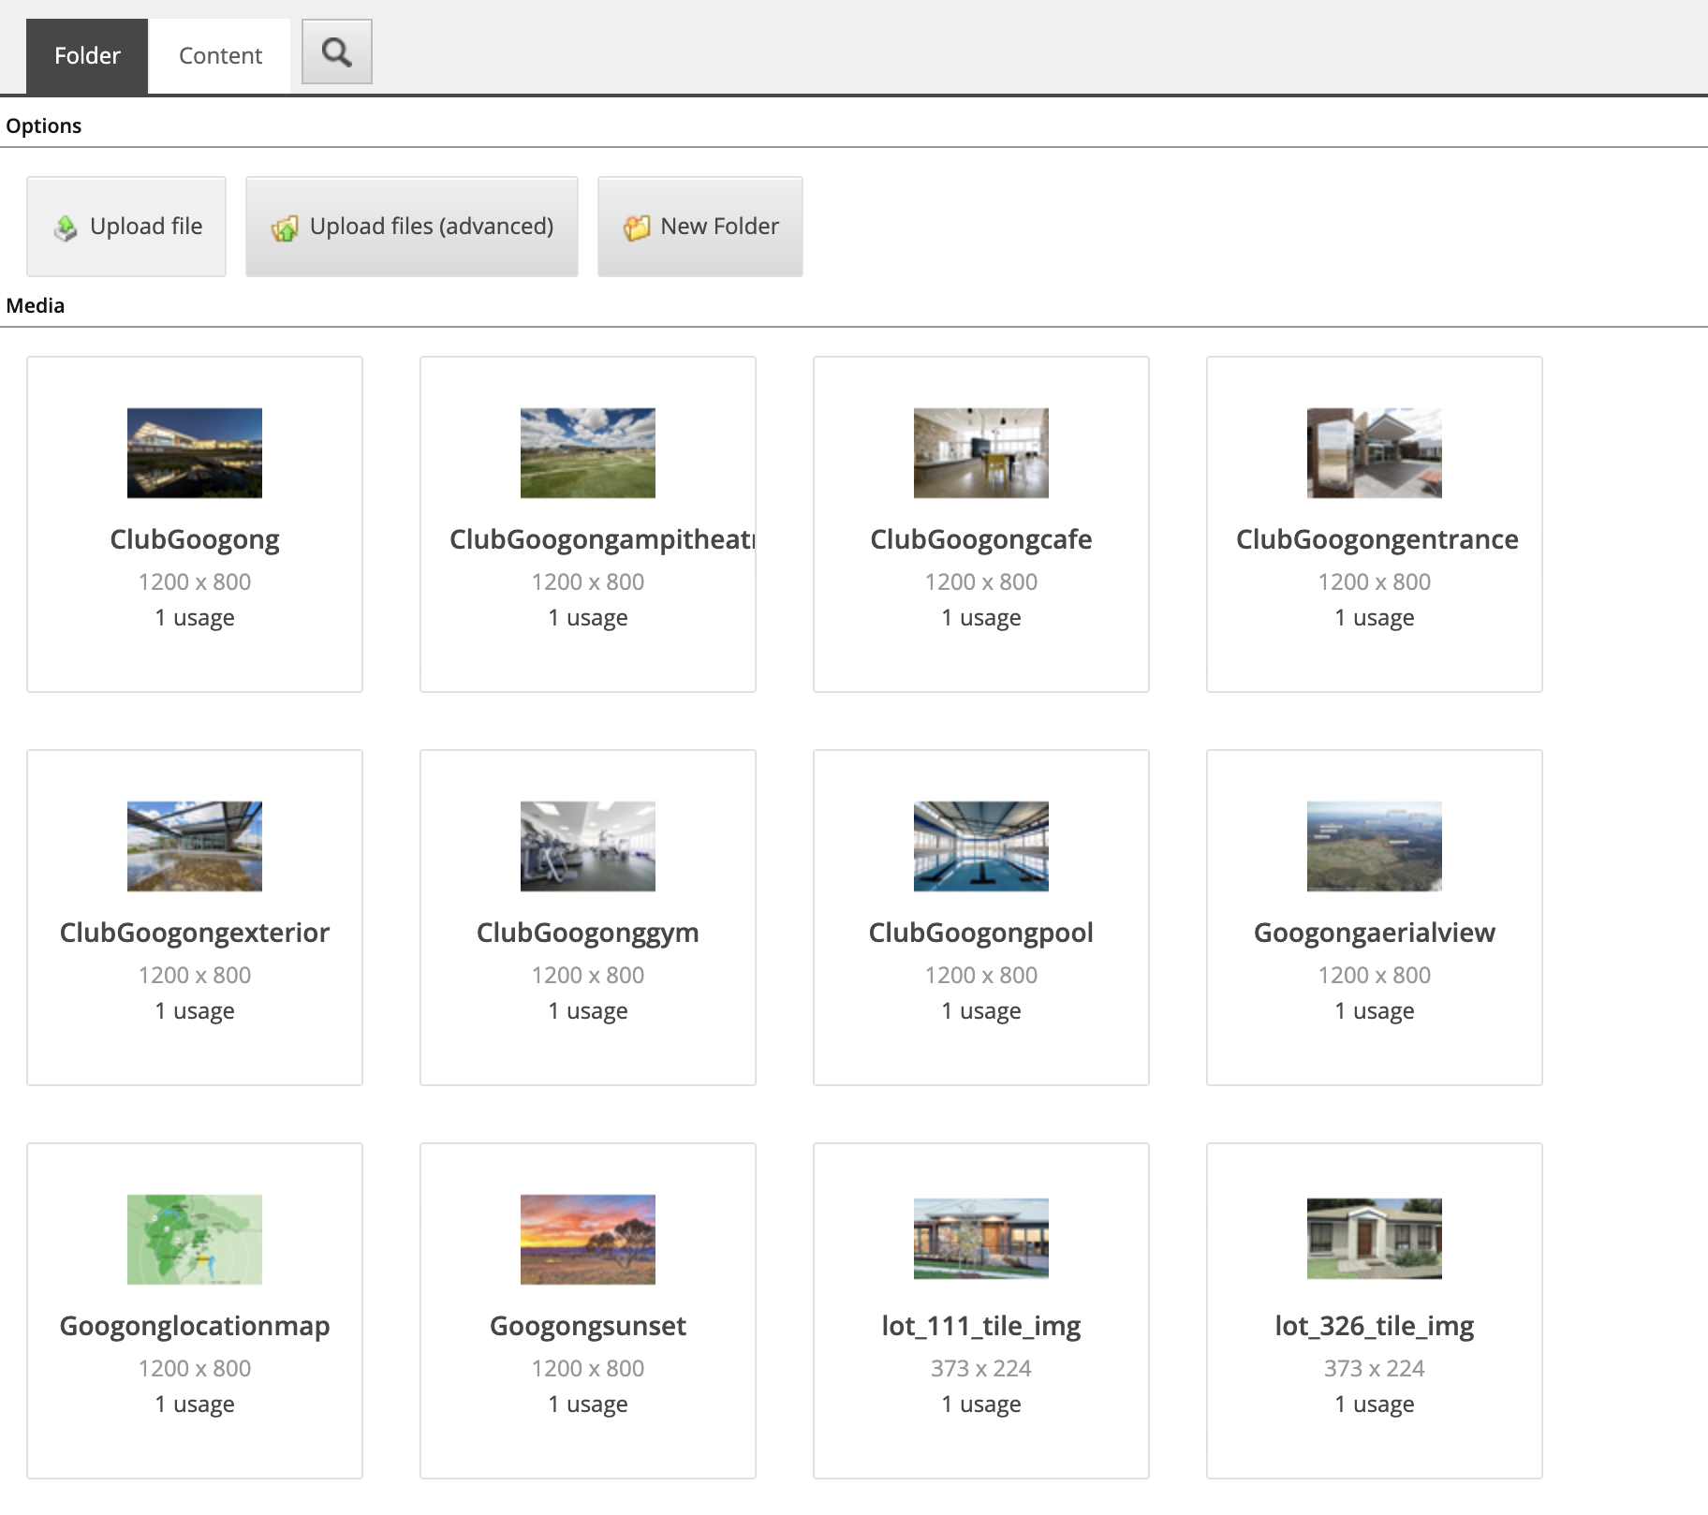

Note: Add Alt text

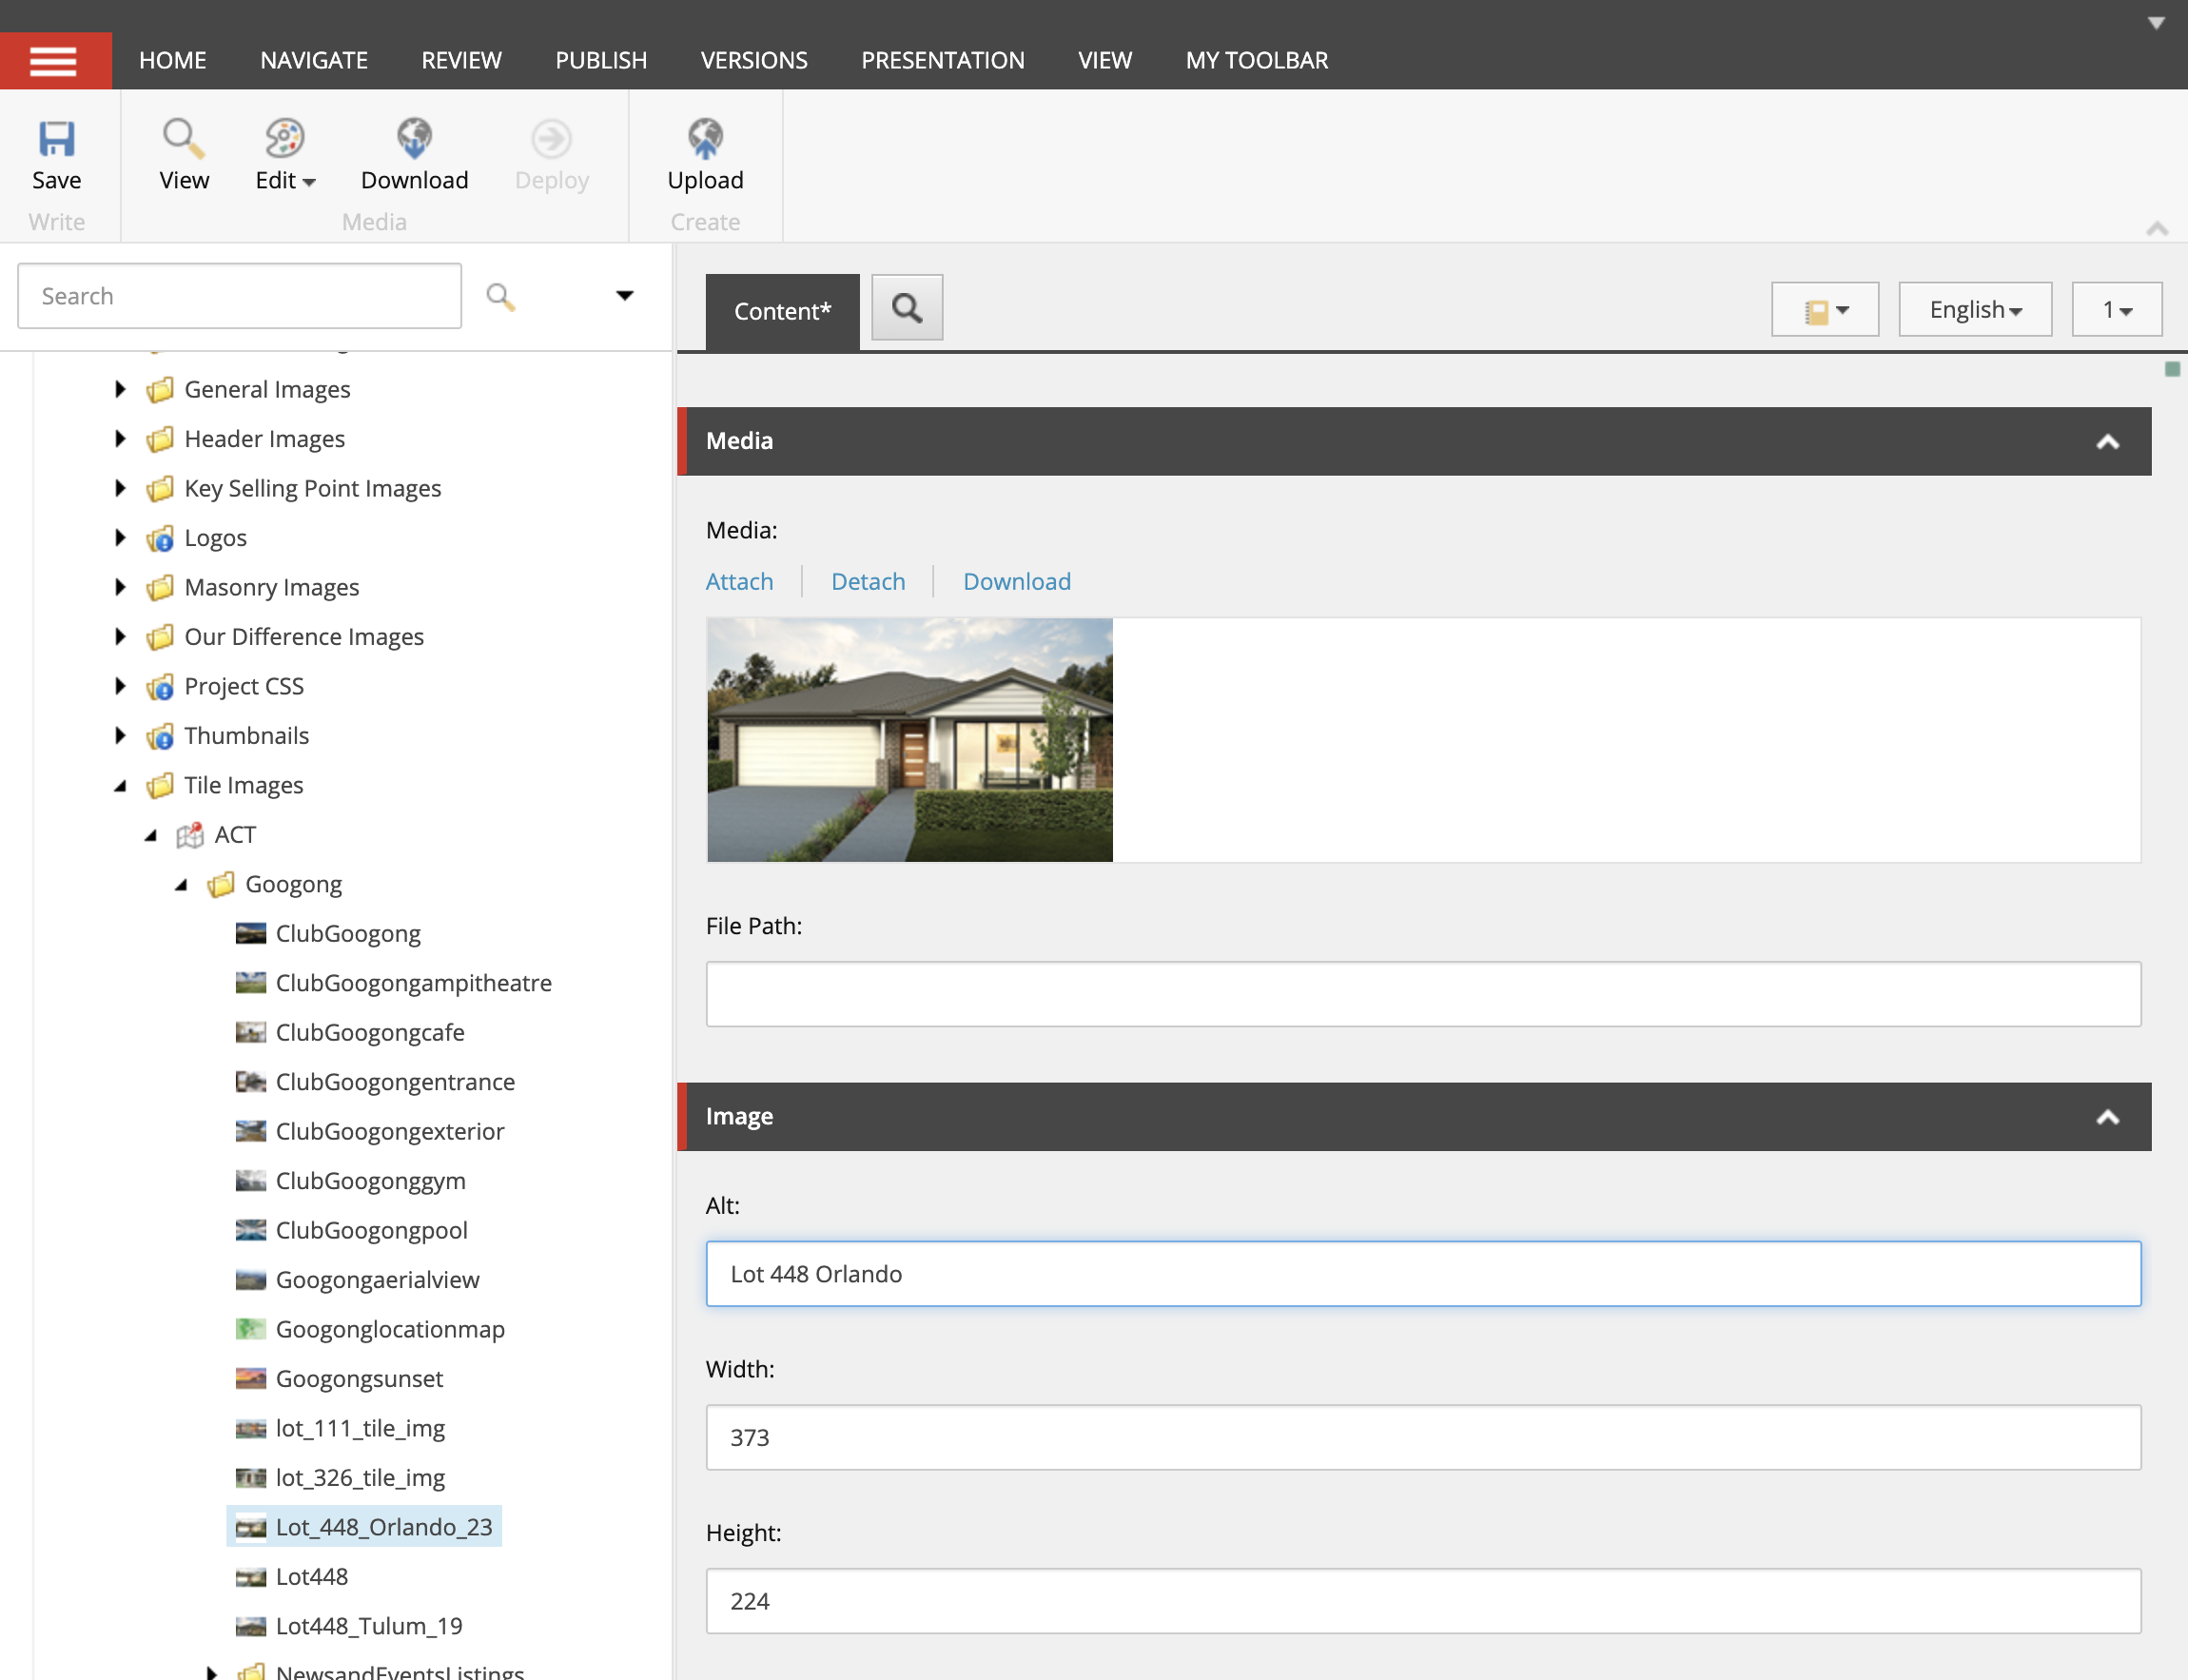

Step 4: Once finished click “Save” and the “Publish -> Publish Item”.

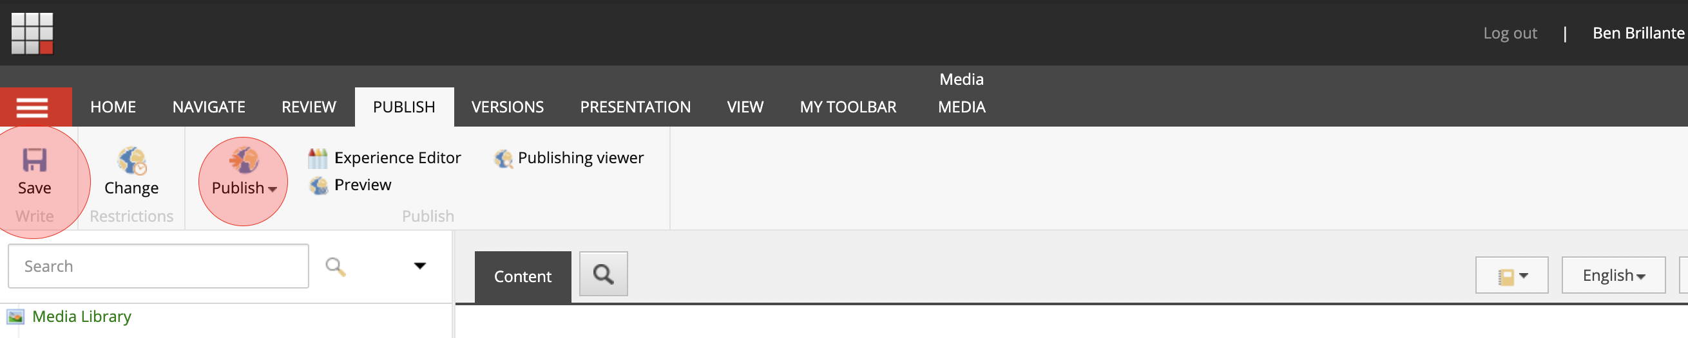

Step 5: To upload the PDF navigate to PEET -> Documents -> ACT -> Googong

Then using the options, click the upload file button.

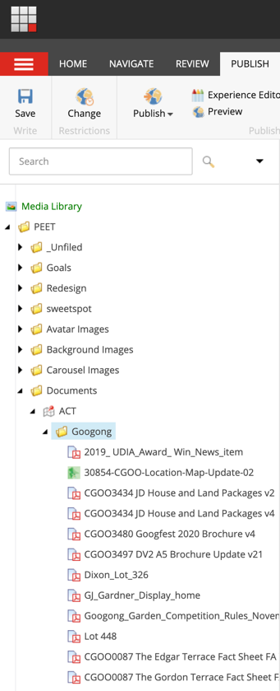

Step 6: Used name conventions: Lot Number – Name of project
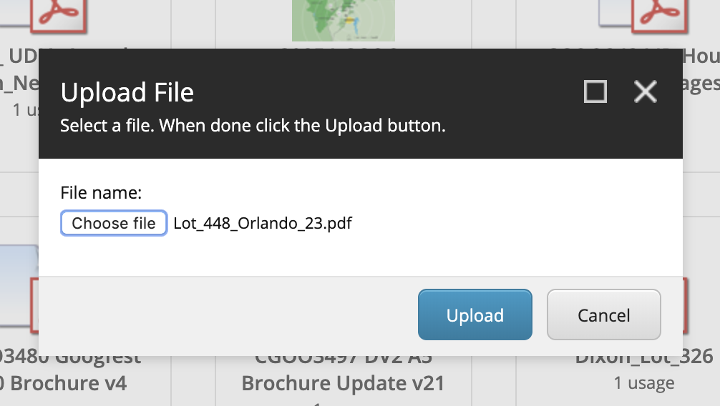

Step 7: Once finished click “Save” and the “Publish -> Publish Item”.

Step 8:
To create a new house and land packages, navigate to Content -> Site Data -> Masonry Items- > ACT and click right to open the insert/ Masonry Item

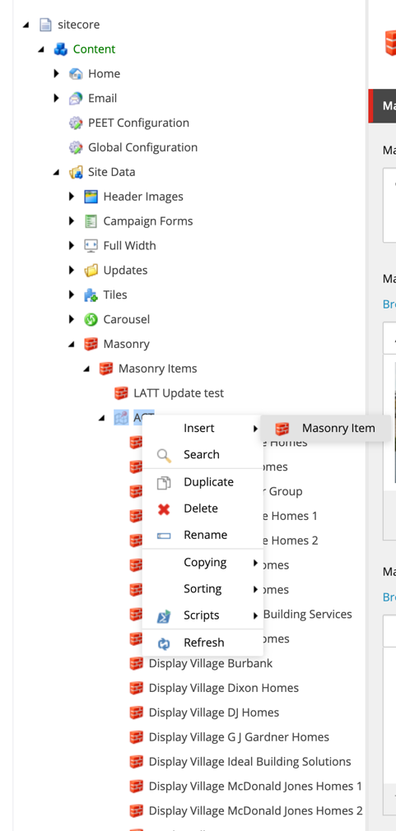

Step 9:
Follow the name conventions: Lot Number – Name of project

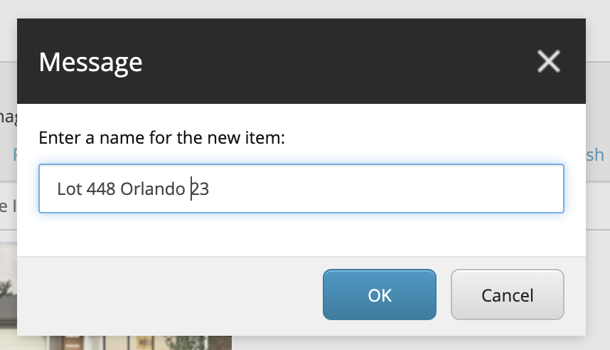

Step 10:
Add the Name of the project followed by the price.
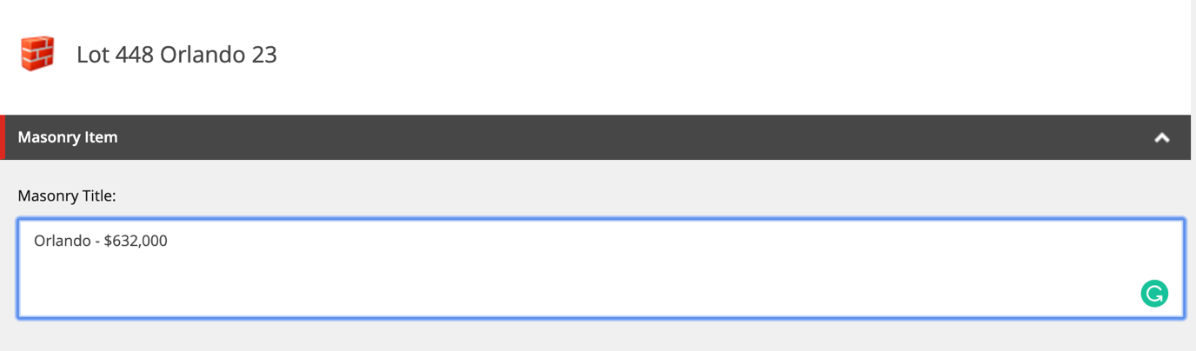

Step 11:
Click the Browse button to add your image.
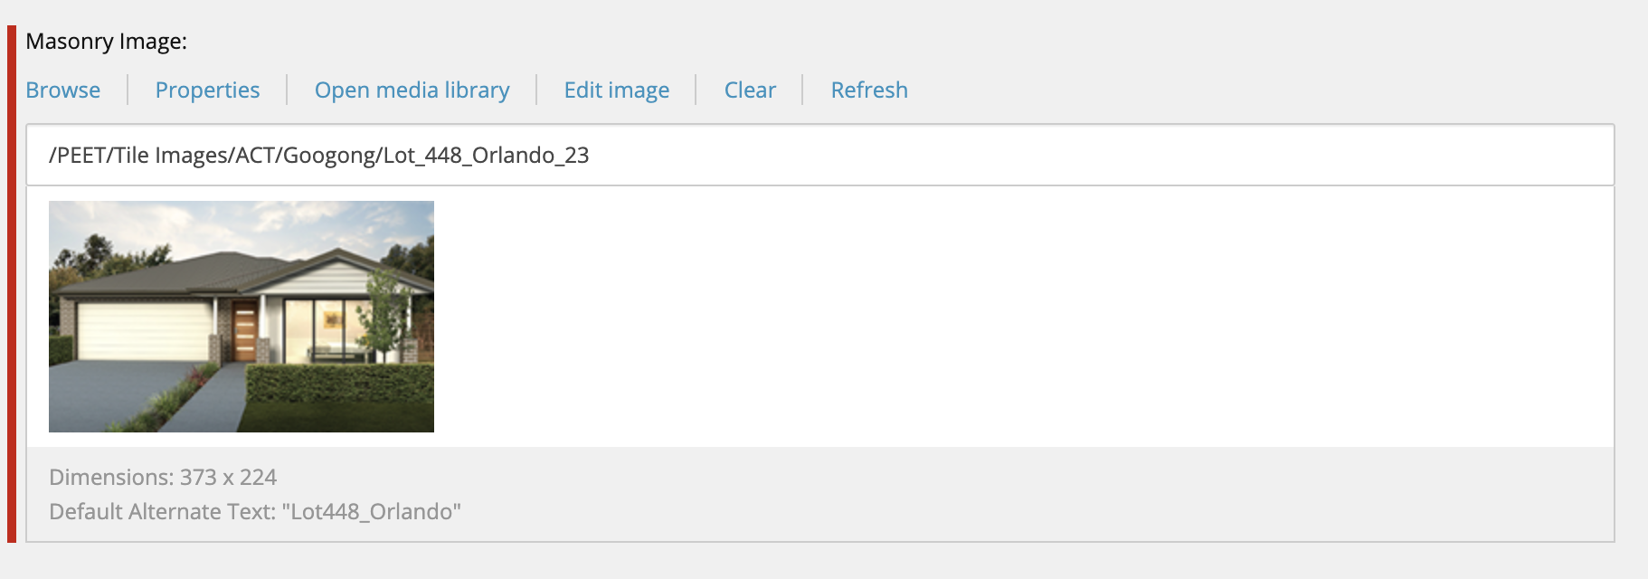

Step 12: Type the Name of the construction company
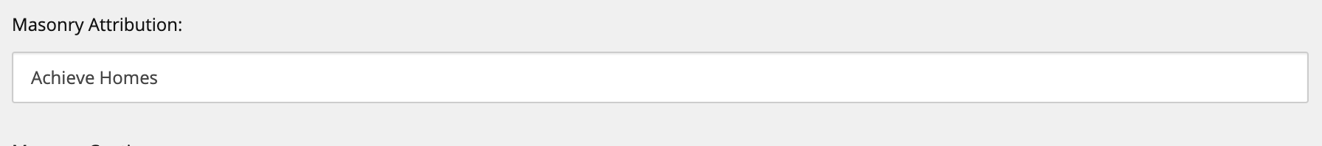

Step 13: On Masonry Caption, click the Edit HTML button and follow the below image, then type characteristics described in the PDF

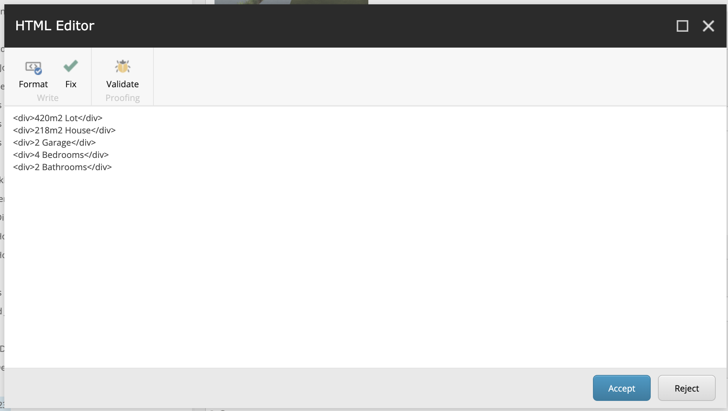
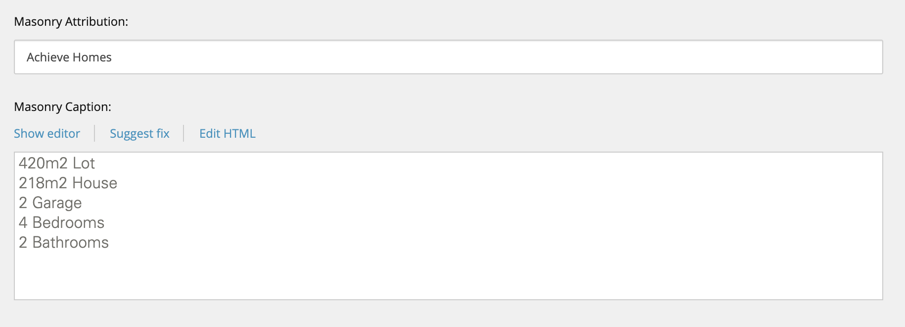

Step 14: To upload the PDF click the Insert Media Link button

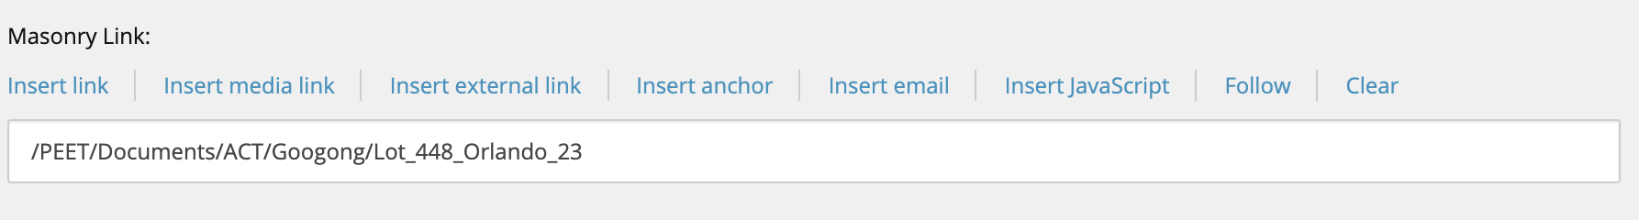

Step 15: Then Type “View Plan” Masonry Link Text

Step 16: Once finished click “Save” and the “Publish -> Publish Item”.

Step 17:
Once your create your house and Land package, , navigate to Masonry Modules, select your new item and click on > to show on the selected items. Then used ^ to positioned in alphabetic order. Once finished Publish tab and click “Save” and then click the Publish -> Publish item.

If you would like to hide Items of the Masonry Modules, simply Click on < Click on the Publish tab and click “Save” and then click the Publish -> Publish item.

